Week 4

PART 1
- What is a nested loop in Python, and how can it be used to iterate over more complex data structures?
- What is the difference between "for" and "while" loops in Python, and when would you use each one?
- Python is a dynamically typed language. What does this statement mean?

PART 2
- Write a program to print numbers from 1 to 10.
- Write a program to print all odd numbers between 1 and 15.
- Write a program to calculate the sum of the first 10 natural numbers.
- Write a program that prompts the user to input a positive integer. It should then print the multiplication table of that number up to 10.
- Write a program to find the factorial value of any number entered through the keyboard.
- Write a program to enter the numbers till the user wants and at the end it should display the count of positive, negative and zeros entered.
- Write a program to print Fibonacci series of n terms where n is input by user:
0 1 1 2 3 5 8 13 24 ....
- Write a python program to reverse the string taken from the user.
- Write a program to print a pattern of numbers like below using a loop:
1
22
333
4444
55555

PART 3

- Write a program to calculate the sum of all numbers between 1 and 100 that are divisible by both 3 and 5 using a loop.
- Write a program to identify whether the user’s input is palindrome or not.
- Write a program that:
(a) Uses a loop to add up all the even numbers between 100 and 200, inclusive.
(b) Sums a series of (positive) integers entered by the user, excluding all numbers that are Greater than 100.
(c) Solves (a) but this time using an infinite loop, break and continue statements.

- The following while loop is meant to multiply a series of integers input by the user, until a sentinel value of 0 is entered. Indicate any errors in the code given. See if you can fix the program and get it running.

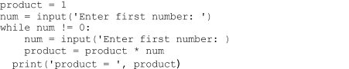

- For each of the following, indicate which the definite loop is, and which an indefinite loop, explain your reasoning.

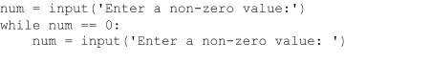
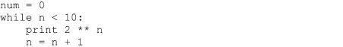
- Write a program to find the largest digit in a number entered by the user using a loop.
- Write a program that uses a loop to count the number of vowels in a given string.
- Write a Python program for a number guessing game where the computer chooses a random number between 1 and 20, and the player has five chances to guess the number. Use a for loop to limit the number of guesses the player can make. After each guess, the program should tell the player whether the guess was too high or too low. If the player correctly guesses the number, the program should congratulate the player and end the game. If the player runs out of guesses, the program should reveal the number and show the player's guesses.

PART 4

- Suppose you are working on a project to develop a simple calculator program in Python. The user is prompted to enter two numbers and then select an operation (addition, subtraction, multiplication, or division). You have already implemented the logic for each operation, but now you need to implement a loop to allow the user to perform multiple calculations without having to restart the program each time.
Write a Python program that uses a loop to repeatedly prompt the user for two numbers and an operation, perform the calculation, and display the result. The program should continue looping until the user enters "q" to quit the program.

- Suppose you are working on a program that simulates a game of dice where the player rolls two six-sided dice and tries to guess the total value. You have already implemented the logic to generate random dice rolls and compare them to the player's guess, but now you need to implement a loop to allow the player to play multiple rounds without having to restart the program each time.

- Write a Python program that uses a loop to repeatedly prompt the player to guess the total value of two dice, generate random dice rolls, compare the rolls to the guess, and display the result. The program should continue looping until the player chooses to quit the game. At the end of each round, the program should display the number of rounds played and the player's win percentage.

